DSA0136-OBJECT ORIENTED PROGRAMMING WITH C++

DAY-1:

1.Write a c++ program for adding the two numbers?

Program:

using namespace std;

#include<iostream>

main()

{

int a,b;

cout<<"enter a and b values";

cin>>a>>b;

if(int(a) && int(b))

{

cout<<a+b;

}

else

{

cout<<"not valid";

}

}

OUTPUT:

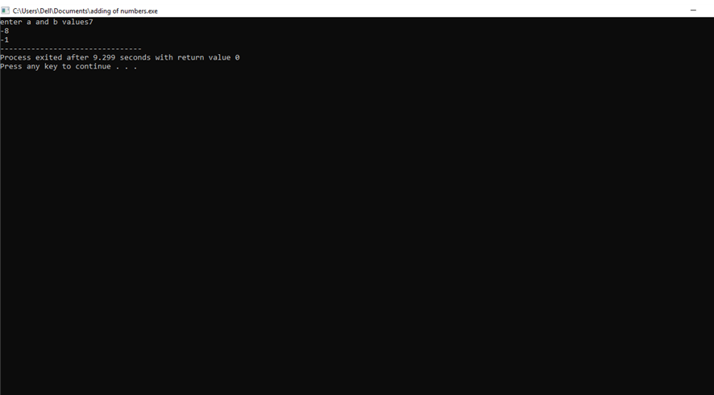

DAY-2

1.wite a c++ program for eligible for vote?

Condition-1:the value should be integer.

Condition-2:the number should be positive number?

PROGRAM:

using namespace std;

#include<iostream>

int main()

{

int age;

cout<<"enter the age";

cin>>age;

if(age>0 && int(age))

{

if (age>=18)

{

cout<<"eligible for vote";

}

else

{

cout<<"not eligible";

}

}

else

{

cout<<"not valid";

}

}

OUTPUT:

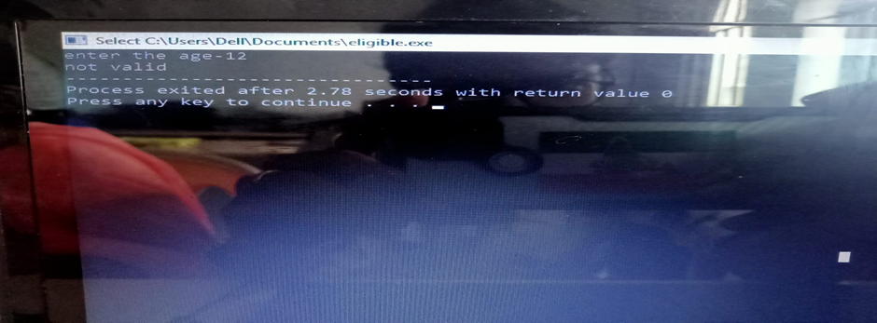

2.write the c++ program to show that the given number is even or odd ?

Condition 1:it should be integer number.

PROGRAM:

using namespace std;

#include<iostream>

int main()

{

int num,a;

cout<<"enter the number";

cin>>num;

if (int(num))

{

if(num%2==0)

{

cout<<"even number";

}

else

{

cout<<"odd number";

}

}

else

{

cout<<"not valid";

}

}

OUTPUT:

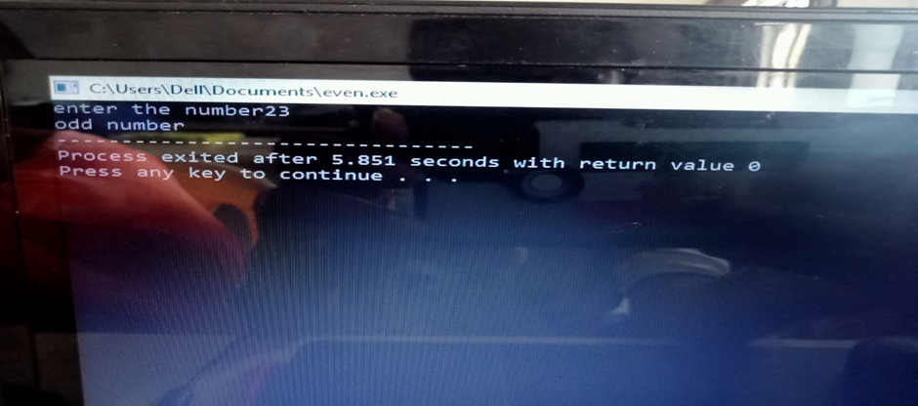

3.Write the c++ program to find the area of the circle and circumference of the circle using switch case statement?

PROGRAM:

using namespace std;

#include<iostream>

int main()

{

float r,PI=3.14;

int exp;

cout<<"enter the radius";

cin>>r;

cout<<"enter the choice";

cin>>exp;

switch(exp)

{

case 1:

{

cout<<"area"<<3.14\*r\*r;

break;

}

case 2:

{

cout<<"circumference"<<2\*3.14\*r;

break;

}

default:

{

cout<<"enter the correct choice";

}

}

}

OUTPUT:

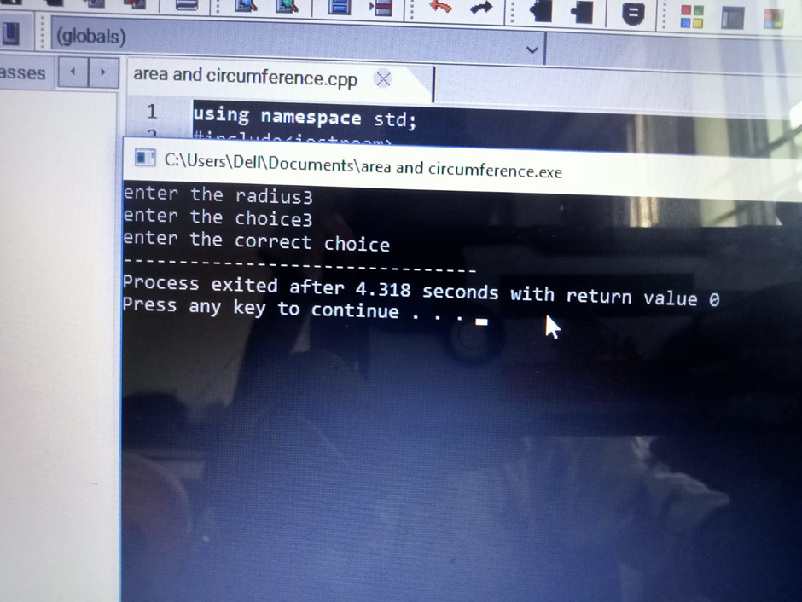

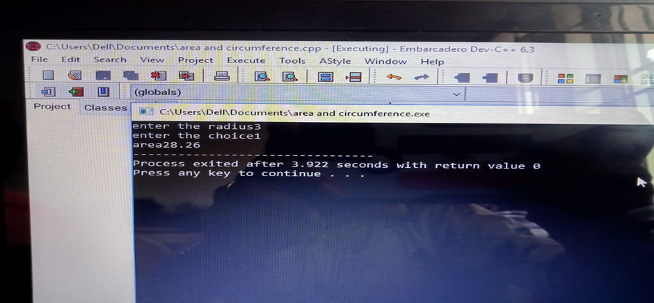

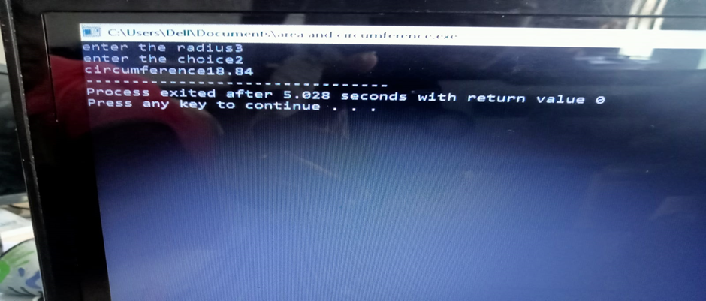

4.write a c++ program for finding the greatest among three numbers?

Conditions:

1.x=5;y=7;z=-9

2.x=0.01;y=0.09;z=-0.03

3.x=-9;y=-7;z=-10

4.x=a;y=b;z=c

Program:

using namespace std;

#include<iostream>

int main()

{

float x,y,z;

cout<<"enter the x,y and z: ";

cin>>x>>y>>z;

if (float(x) && float(y) && float(z))

{

if(x>y && x>z)

{

cout<<"x is the greatest";

}

else if(y>x && y>z)

{

cout<<"y is greatest number";

}

else

{

cout<<"z is the greatest number";

}

}

else

{

cout<<"not valid";

}

}

OUTPUT:

1.

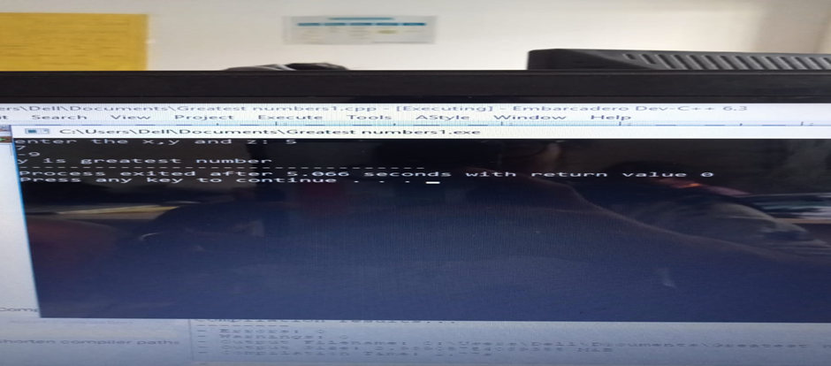

2.

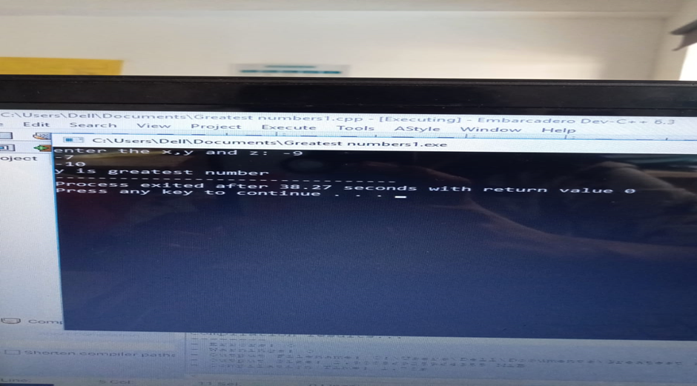

5. Write the c++ program for student report read three marks and calculate the grade?

Conditions:

1. m1=80,m2=60,m3=90;

2. m1=-10,m2=20,m3=100;

3. m1=150,m2=10,m3=100;

4. m1=80,m2=30,m3=60;

5. m1=x;m2=y;m3=z;

Program:

using namespace std;

#include<iostream>

int main()

{

int m1,m2,m3,regno;

float total,avg;

cout<<"enter the regno";

cin>>regno;

cout<<"enter the three subject marks";

cin>>m1>>m2>>m3;

total=m1+m2+m3;

if (m1>=50 && m1<=100)

{

avg=total/3;

if(avg>=90)

{

cout<<"grade A";

}

else if(avg>=80 && avg<90)

{

cout<<"grase B";

}

else if(avg>=70 && avg<80)

{

cout<<"grade C";

}

else if(avg>=60 && avg<70)

{

cout<<"grade D";

}

else

{

cout<<"fail";

}

}

else

{

cout<<"enter the correct marks";

}

}

OUTPUT:

1.

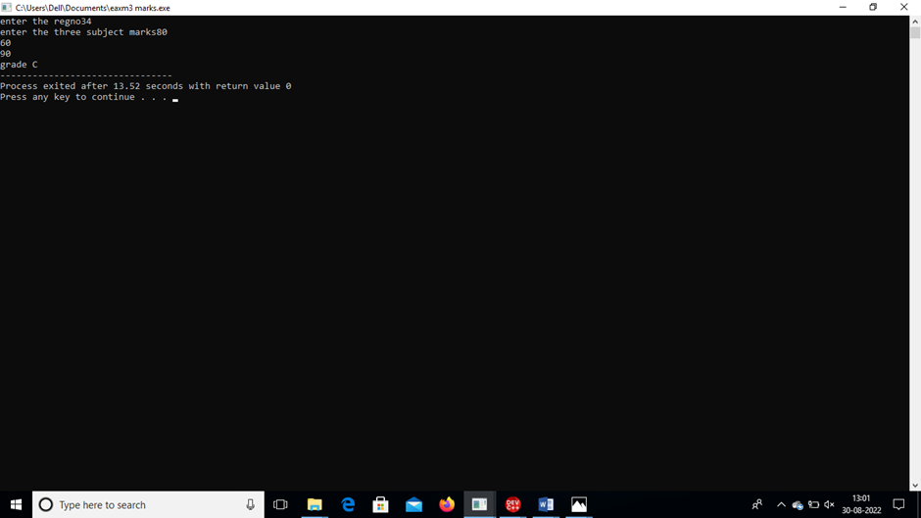

2.



3.

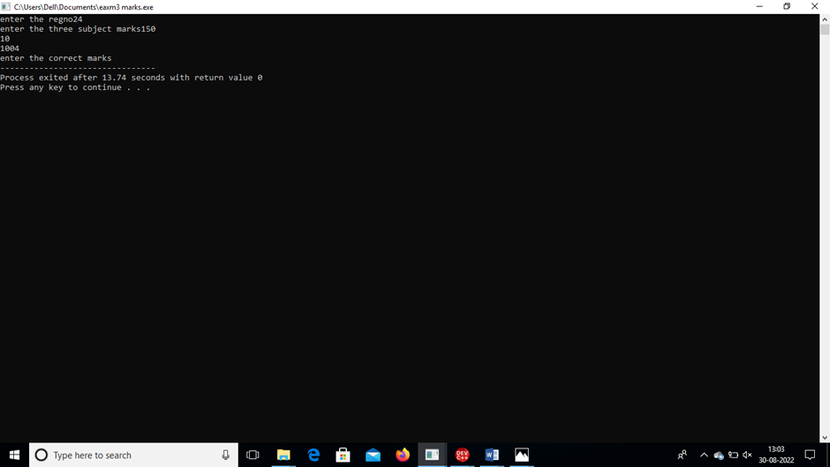

4.

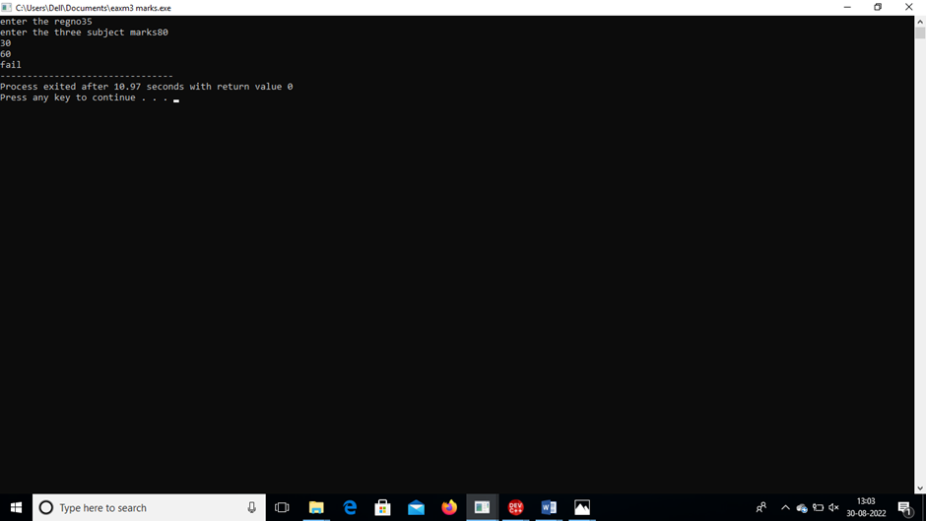

5.

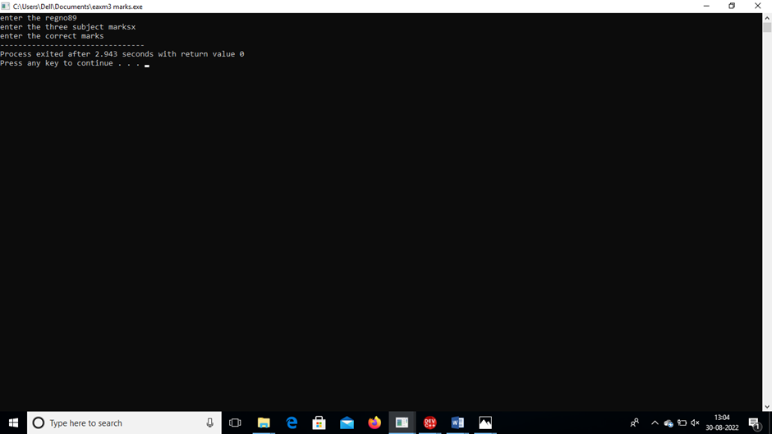

DAY-3

1.Write the c++ program to find the volume of the cone using class and object?

Program:

using namespace std;

#include<iostream>

class volume

{

float r,h,v;

public:

void getdata();

void display();

};

void volume::getdata()

{

cout<<"enter the r and h values: ";

cin>>r>>h;

}

void volume::display()

{

cout<<"volume of the cone";

v=(3.14\*r\*r\*h)/3;

cout<<v;

}

int main()

{

volume z;

z.getdata();

z.display();

}

OUTPUT:

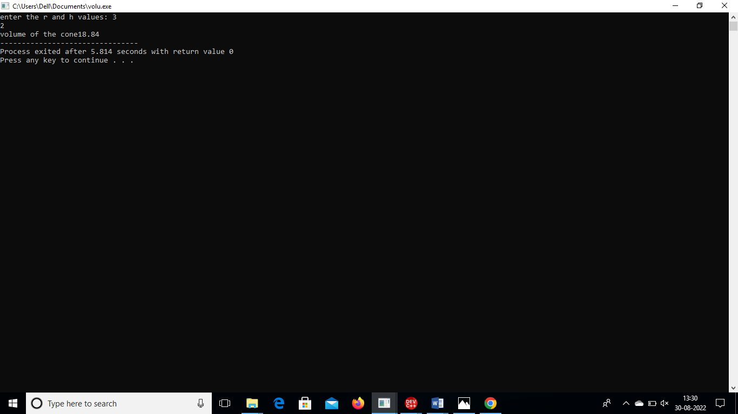

2.Write the c++ program to calculate the simple and compound interest?

Program:

using namespace std;

#include<iostream>

#include<math.h>

class interest

{

double P,R,T;

double A,N,M;

public:

void getdata();

void display();

};

void interest::getdata()

{

cout<<"enter the P,R and T values: ";

cin>>P>>R>>T;

}

void interest::display()

{

cout<<"simple interest";

N=(P\*R\*T)/100;

cout<<N;

cout<<"compound interest";

A=P\*(pow((1+R/100),T));

M=A-P;

cout<<M;

}

int main()

{

interest K;

K.getdata();

K.display();

}

OUTPUT:

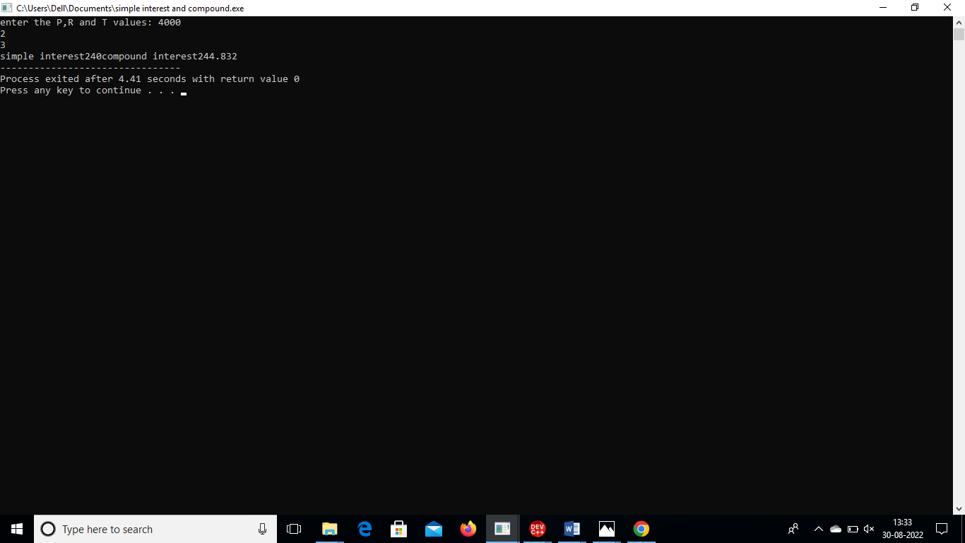3.Write the c++ program to perform sum of two numbers using object and class?

Program:

using namespace std;

#include<iostream>

class add

{

float a,b,d;

public:

void getdata();

void display();

};

void add::getdata()

{

cout<<"enter the a and b values: ";

cin>>a>>b;

}

void add::display()

{

cout<<"sum of two numbers";

d=a+b;

cout<<d;

}

int main()

{

add z;

z.getdata();

z.display();

}

OUTPUT:

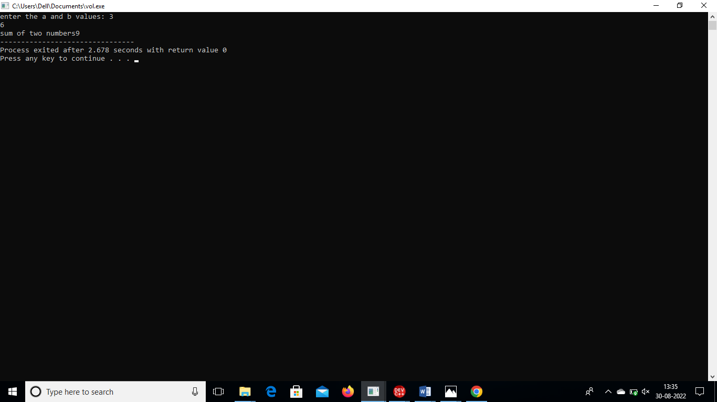

4.Write the c++ program to find the greatest number of three numbers using class and object?

Program:

using namespace std;

#include<iostream>

class greatest

{

int a,b,c;

public:

void getdata();

void display();

};

void greatest::getdata()

{

cout<<"enter the a,b and c values: ";

cin>>a>>b>>c;

}

void greatest::display()

{

cout<<"greatest of three numbers is:\n";

if(a>b && a>c)

{

cout<<"a is greatest number";

}

else if(b>a && b>c)

{

cout<<"b is greatest number";

}

else if(c>a && c>b)

{

cout<<"c is greatest number";

}

else

{

cout<<"enter the correct values";

}

}

int main()

{

greatest h;

h.getdata();

h.display();

}

OUTPUT:

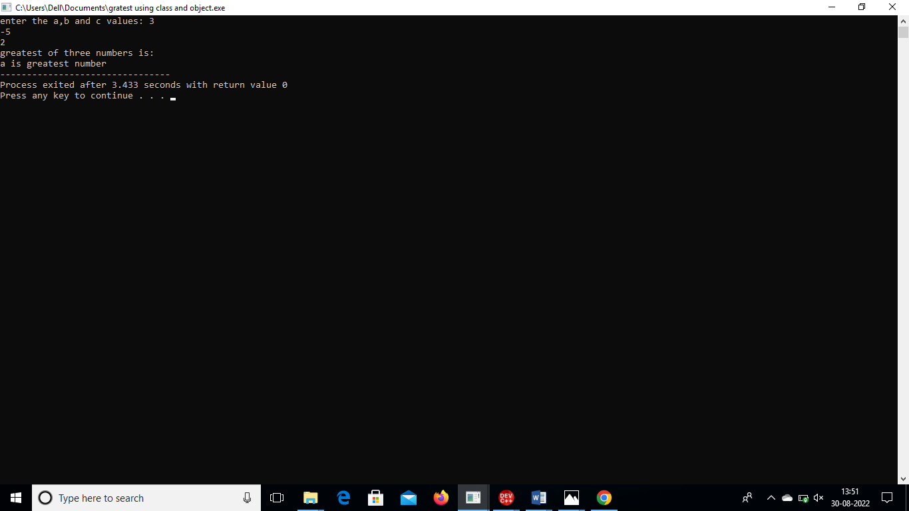

5.Write a c++ program to calculate the area of rectangle using constructor overloading?

Program:

using namespace std;

#include<iostream>

class rectangle

{

int l,b,x;

public:

rectangle();

rectangle(int,int);

};

rectangle::rectangle()

{

}

rectangle::rectangle(int l,int b)

{

cout<<"area of rectangle";

x=l\*b;

cout<<x;

}

int main()

{

rectangle myarea(10,20);

return 0;

}

OUTPUT:

